Function Point Analysis was initially developed by Allan J. Albrecht in 1979 at IBM and it has been further modified by the International Function Point Users Group (IFPUG). The initial definition is given by Allan J. Albrecht.
Functional Point Analysis gives a dimensionless number defined in function points which we have found to be an effective relative measure of function value delivered to our customer.

Objectives of Functional Point Analysis
- The objective of FPA is to measure the functionality that the user requests and receives.
- The objective of FPA is to measure software development and maintenance independently of the technology used for implementation.
- It should be simple enough to minimize the overhead of the measurement process.
- It should be a consistent measure among various projects and organizations.

Types of Functional Point Analysis
There are basically two types of Functional Point Analysis, that are listed below.
- Transactional Functional Type
- Data Functional Type

Transactional Functional Type
- External Input (EI): EI processes data or control information that comes from outside the application’s boundary. The EI is an elementary process.
- External Output (EO): EO is an elementary process that generates data or control information sent outside the application’s boundary.
- External Inquiries (EQ): EQ is an elementary process made up of an input-output combination that results in data retrieval.

Data Functional Type
- Internal Logical File (ILF): A user-identifiable group of logically related data or control information maintained within the boundary of the application.
- External Interface File (EIF): A group of users recognizable logically related data allusion to the software but maintained within the boundary of another software.
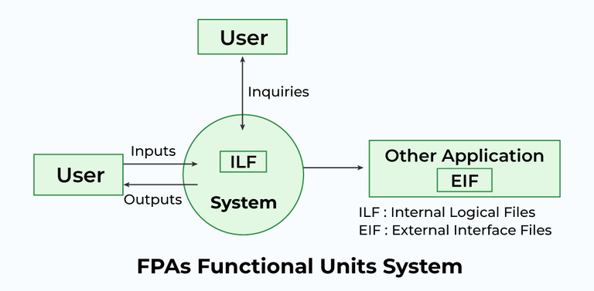
Functional Point Analysis

Benefits of Functional Point Analysis
- FPA is a tool to determine the size of a purchased application package by counting all the functions included in the package.
- It is a tool to help users discover the benefit of an application package to their organization by counting functions that specifically match their requirements.
- It is a tool to measure the units of a software product to support quality and productivity analysis.
- It is a vehicle to estimate the cost and resources required for software development and maintenance.
- It is a normalization factor for software comparison.

Characteristics of Functional Point Analysis
We calculate the functional point with the help of the number of functions and types of functions used in applications. These are classified into five types.
Measurement Parameters | Examples
Number of External Inputs (EI) | Input screen and tables
Number of External Output (EO) | Output screens and reports
Number of external inquiries (EQ) | Prompts and interrupts
Number of internal files (ILF) | Databases and directories
Number of external interfaces (EIF) | Shared databases and shared routines
Functional Point helps in describing system complexity and also shows project timelines. It is majorly used for business systems like information systems.

Weights of 5 Functional Point Attributes
Measurement Parameter | Low | Average | High
Number of external inputs (EI) | 3 | 4 | 6
Number of external outputs (EO) | 4 | 5 | 7
Number of external inquiries (EQ) | 3 | 4 | 6
Number of internal files (ILF) | 7 | 10 | 15
Number of External Interfaces (EIF) | 5 | 7 | 10
Functional Complexities help us in finding the corresponding weights, which results in finding the Unadjusted Functional point (UFp) of the Subsystem. Consider the complexity as average for all cases. Below mentioned is the way how to compute FP.
Measurement Parameter | Count |  | Weighing Factor
Measurement Parameter | Count | Total_Count | Simple | Average | Complex
Number of external inputs (EI) | 32 | 32*4=128 | 3 | 4 | 6
Number of external outputs (EO) | 60 | 60*5=300 | 4 | 5 | 7
Number of external inquiries (EQ) | 24 | 24*4=96 | 3 | 4 | 6
Number of internal files (ILF) | 8 | 8*10=80 | 7 | 10 | 15
Number of external interfaces (EIF) | 2 | 2*7=14 | 5 | 7 | 10
Algorithms used Count total → |  | 618
From the above tables, Functional Point is calculated with the following formula
FP = Count-Total * [0.65 + 0.01 * ⅀(fi)]
= Count * CAF
Here, the count-total is taken from the chart.
CAF = [0.65 + 0.01 * ⅀(fi)]
- ⅀(fi) = sum of all 14 questions and it also shows the complexity factor – CAF.
- CAF varies from 0.65 to 1.35 and ⅀(fi) ranges from 0 to 70.
- When ⅀(fi) = 0, CAF = 0.65 and when ⅀(fi) = 70, CAF = 0.65 + (0.01*70) = 0.65 + 0.7 = 1.35

Questions on Functional Point
1. Consider a software project with the following information domain characteristic for the calculation of function point metric.
Number of external inputs (I) = 30
Number of external output (O) = 60
Number of external inquiries (E) = 23
Number of files (F) = 08
Number of external interfaces (N) = 02
It is given that the complexity weighting factors for I, O, E, F, and N are 4, 5, 4, 10, and 7, respectively. It is also given that, out of fourteen value adjustment factors that influence the development effort, four factors are not applicable, each of the other four factors has value 3, and each of the remaining factors has value 4. The computed value of the function point metric is _____. [GATE CS 2015]
(A) 612.06
(B) 212.05
(C) 305.09
(D) 806.9
Solution: Correct Answer is (A).
For more, refer to GATE CS 2015 | Question 65.
2. While estimating the cost of the software, Lines of Code(LOC) and Function Points (FP) are used to measure which of the following? [UGC-NET CSE 2013]
(A) Length of Code
(B) Size of Software
(C) Functionality of Software
(D) None of the Above
Solution: Correct Answer is (B).
3. In functional point analysis, the number of complexity adjustment factors is [UGC-NET CS 2014]
(A) 10
(B) 12
(C) 14
(D) 20
Solution: Correct Answer is (C).

FAQs on Functional Point

1. What do you mean by Functional Point?
Answer:
Functional Point basically determines the size of the application system on the basis of the functionality of the system.

2. How do you find the Functional Point?
Answer:
The functional Point is calculated with the total count factor. It is simply calculated using the formula FP = TC * [0.65 + 0.01*⅀(Xi)].

3. List the five components of the Functional Point?
Answer:
The five components of the functional point are listed below.
- Internal Logical Files (ILF)
- External Interface Files (EIF)
- External Inputs (EI)
- External Outputs (EO)
- External Enquiries (EQ)

